LinkedIn Profile Optimisation
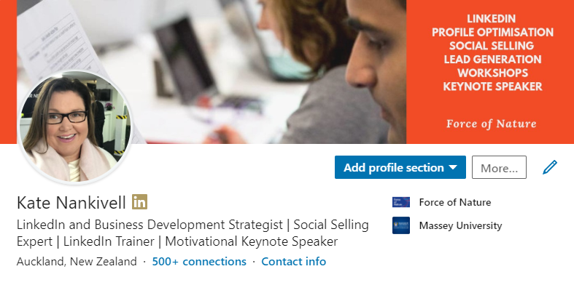
Online Workshop
The What
Learn how to optimise your own LinkedIn profile in alignment with your business or sales goals. You save by learning how and doing the work yourself.

The Who
Great for business owners, professionals and sales people on a budget.

The How
Learn from the comfort of your own desk with 3 x group Zoom sessions.
- Monday May 11th 9:30 – 11:00AM
- Wednesday May 13th 9:30 – 11:00AM
- Wednesday May 20th 9:30 – 11:00AM
Sessions are spaced out to allow you time to work on your profile.

VIP BONUS 1:1 Feedback Session – Valued at $300.00
Book a VIP pass and benefit from a ½ hour one to one laser focused feedback session on your LinkedIn profile.

The Investment

GA Ticket | $495 + GST per person | 3 x Zoom Sessions
VIP Ticket | $595 + GST per person | 3 x Zoom Sessions  BONUS 1:1 Feedback Session

How Do I Book?
Call Kate on 021 245 2777 or email kate@forceofnature.co.nz to make a booking.
Client Testimonials

I produce brand videos for businesses with a focus on authentic and emotive storytelling. I also have an online course, teaching business owners how to make their own content with their smartphones.

I knew LinkedIn was a great place for B2B connections, but I wasn’t leveraging it very well at all. It was all a bit of a mystery to me and I didn’t know where to start.

It’s been amazing doing Kate’s LinkedIn profile optimisation workshop as it’s given me a really solid framework of what I need to be doing to be found on LinkedIn. I can join the workshop from the comfort of my own office on Zoom, and it’s completed over 3 weeks so I can easily fit it into my schedule. I highly recommending working with Kate, she makes LinkedIn easy and fun – I’m very inspired now!
Michelle Sokolich, Show and Tell

I am a Qualified Bookkeeper who has recently started my own Bookkeeping & Admin Business. New to the business world, I lacked confidence on social media and decided to do a LinkedIn Profile Optimisation Online Workshop with Kate Nankivell.

What a great course it is! Kate has shown me so much in a short space of time. I have the confidence now to feel quite proud of my profile. I feel 100 times better! The course its lots of fun and very interactive and can be done in the privacy of your own home if you wish.

I highly recommend you go try out Kate's course. You will be amazed how much more there is to know about LinkedIn.
Noeline Murphy, The Bookie – Bookkeeping & Administration

FAQ’s

Are there payment options?
Yes, to help you get started during these unexpected times we now provide a Lay Buy option when paying through the website.

What is Zoom?
Zoom is an online meeting platform (like Skype) which means that the sessions will be live, and you will have plenty of opportunity for Q&A. You will be sent links and invitations to join the sessions.

When will my 1:1 session be scheduled?
Your 1:1 session is booked in advance when you book your workshop ticket.

Can I change my mind and book a 1:1 after the workshop sessions?
Yes, you can. If you decide to book a 1:1 laser focused feedback session after the workshop, you will pay $300.00 + GST for the session.

